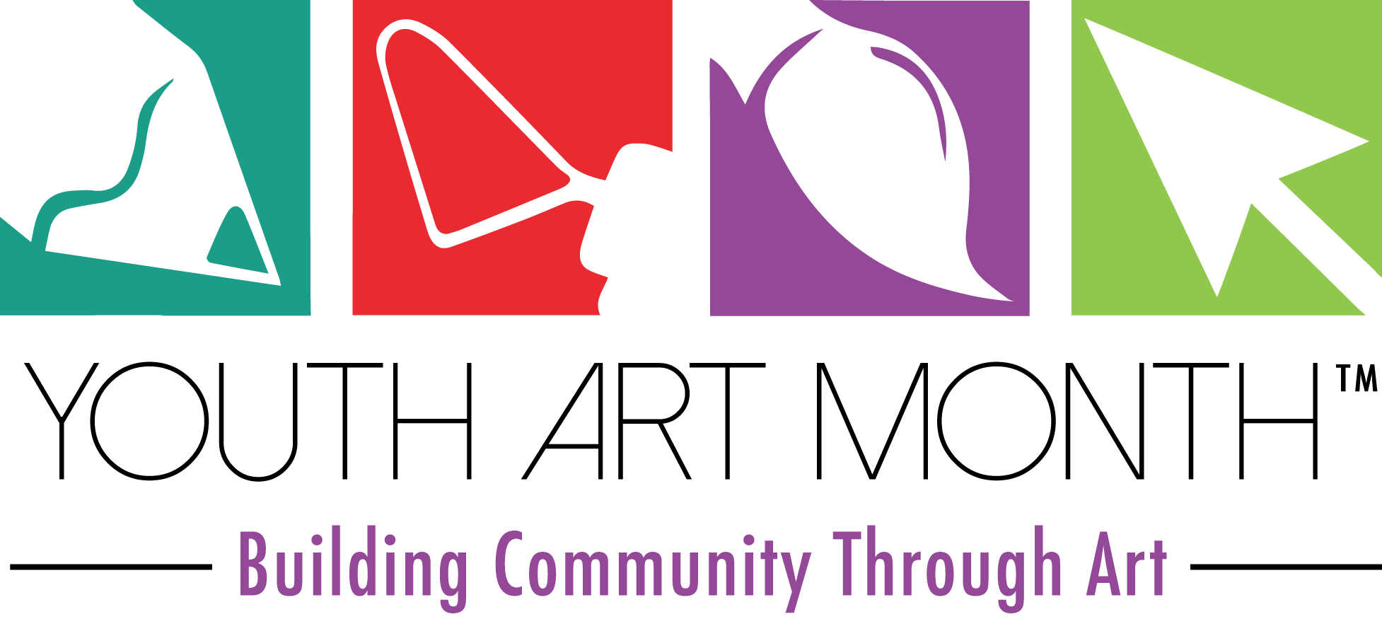

DATE
ADDRESS
PHONE/FAX
EMAIL

Dear
It’s almost time to celebrate Youth Art Month!
This annual celebration directs attention to the value of visual art education in a student’s overall success. A report from the Arts Education Partnership published in April 2013 titled “Preparing Students for the Next America – The Benefits of an Arts Education” highlighted the importance of an education that includes the arts.
“America’s global stature, culture of innovation, and entrepreneurial spirit depend on the strength of a world-class education system. Perhaps now more than ever – as the country becomes increasingly diverse, the world more interconnected, and the workplace more oriented around technology and creativity – arts education is key to such a system and to ensuring students’ success in school, work, and life.” **
Youth Art Month is an annual celebration supported through The Council for Art Education to emphasize the value of art education and encourage support for quality school art programs. It provides a forum for acknowledging skills that are fostered through experience in the visual arts that are not possible in other subjects in the curriculum.
Youth Art Month directs attention to the value of a visual art education. It encourages commitment to the arts by students, community organizations, and individuals.
A variety of activities across the country at the local and state level support Youth Art Month, including a student flag design program supporting the annual theme. The winning design for the state is made into a flag, and the flag is displayed and recognized at the National Art Education Association Conference in March.
Please join us in our efforts to spotlight art education by issuing a Proclamation recognizing Youth Art Month.
Thank you for your time and consideration and I look forward to hearing from your office in the near future.

Sincerely,
Name
Address
Email
Phone

