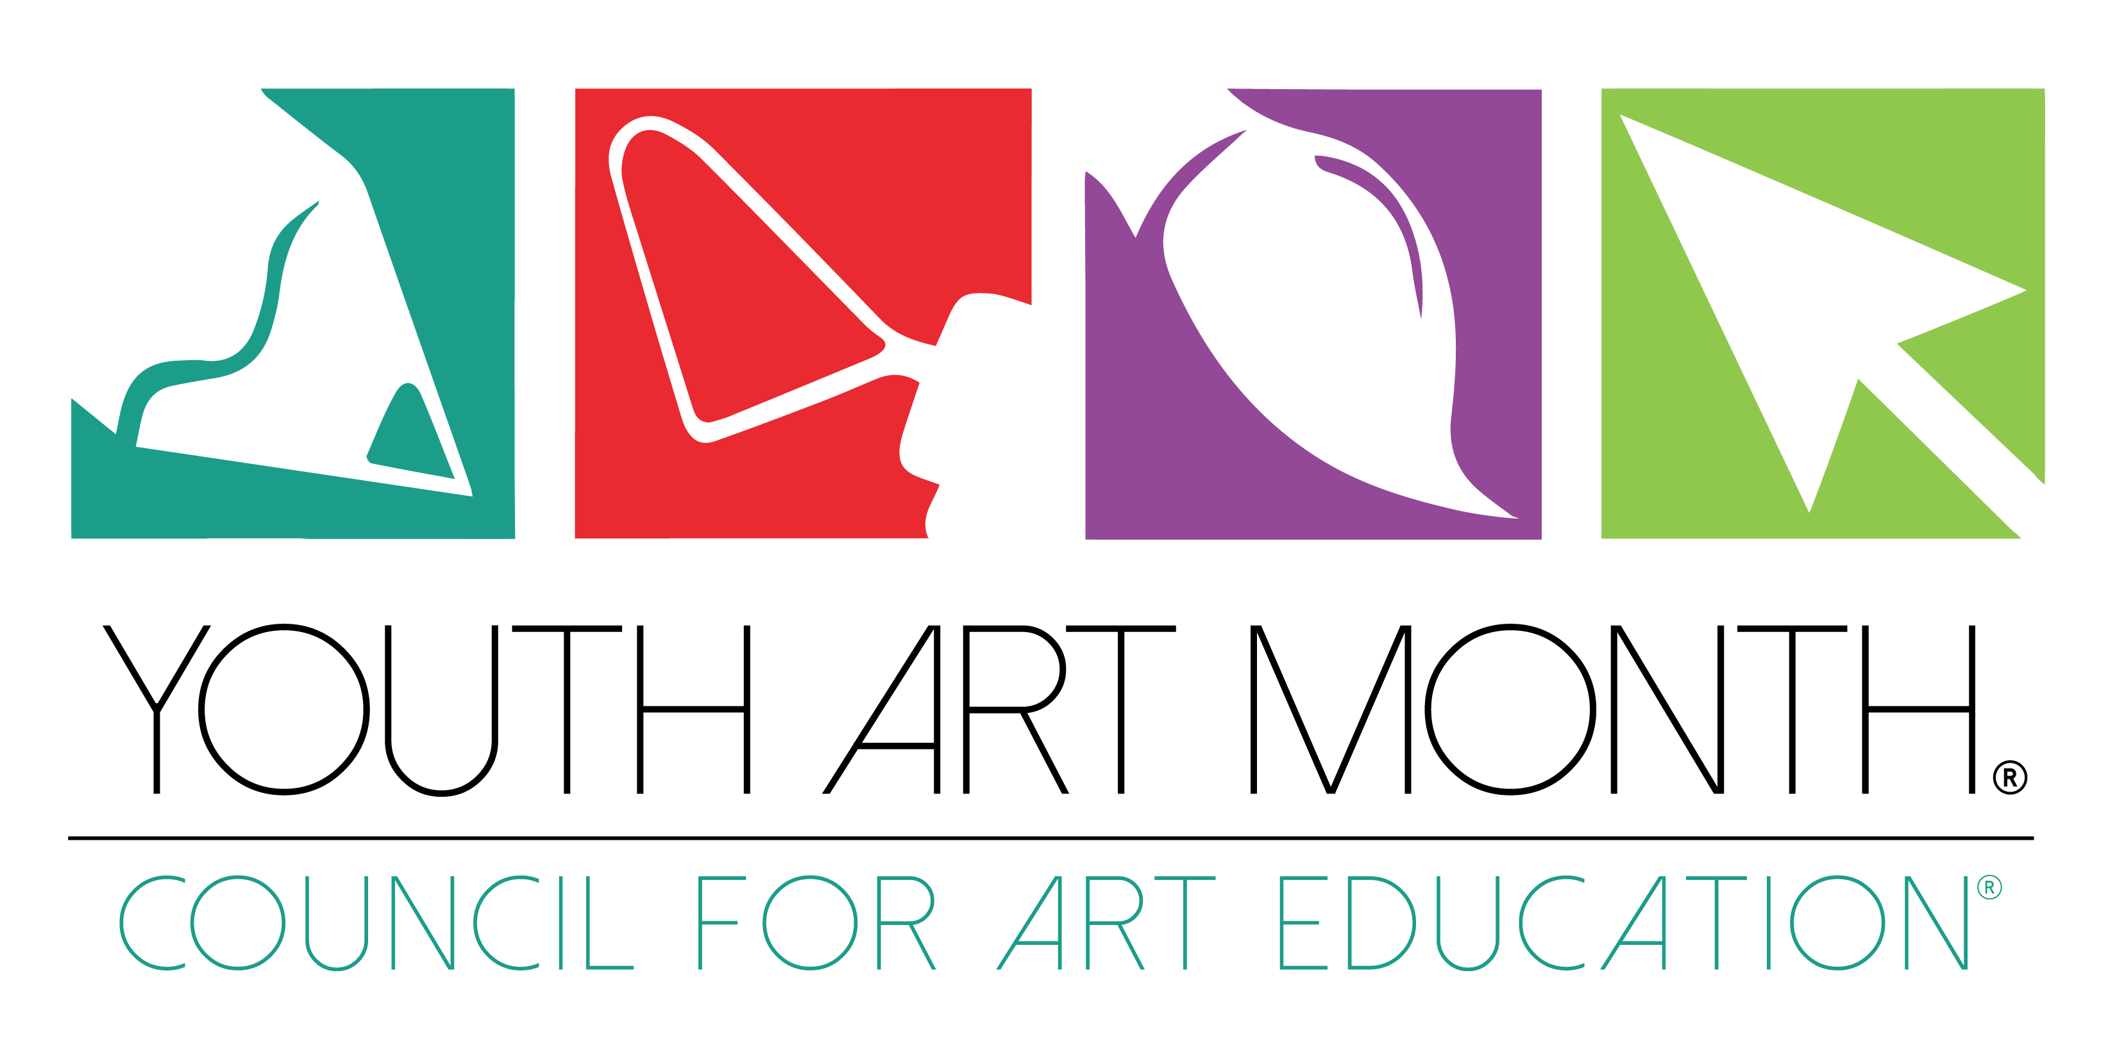

YOUTH ART MONTH ENDORSEMENT

WHEREAS: Art education is a viable academic endeavor and contributes educational benefits to all elementary and secondary students including the following:
- Art education develops students’ creative problem-solving and critical thinking abilities;
- Art education teaches sensitivity to beauty, order, and other expressive qualities;
- Art education gives students a deeper understanding of multi-cultural values and beliefs;
- Art education reinforces and brings to life what students learn in other subjects;
- Art education interrelates student learning in art production, art history, art criticism and aesthetics and

WHEREAS: Our national leaders have acknowledged the necessity of including arts experiences in all students’ education, and

WHEREAS: MARCH is officially recognized as YOUTH ART MONTH, I endorse the observance of Youth Art Month and encourage the support of quality school art programs for children and youth.

SIGNED ____________________________________________________

POSITION ___________________________________________________

DATE _______________________________________________________

